KS-03
2016 IE Strategy Memorandum
Updated on 5/19/16
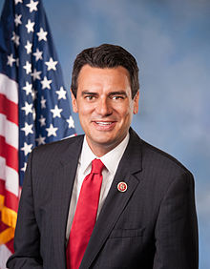


JAY SIDIE KEVIN YODER
CoH: CoH: $2,372,292
Date: 5/19/16 Date: 4/22/16
Occupation: Businessman Occupation: Congressman

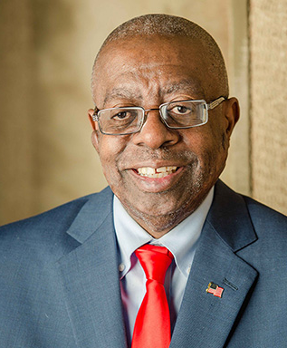

NATHANIEL MCLAUGHLIN
CoH: $469
Date: 4/22/16
Occupation: Hotel Executive

SECTION I: Race Overview
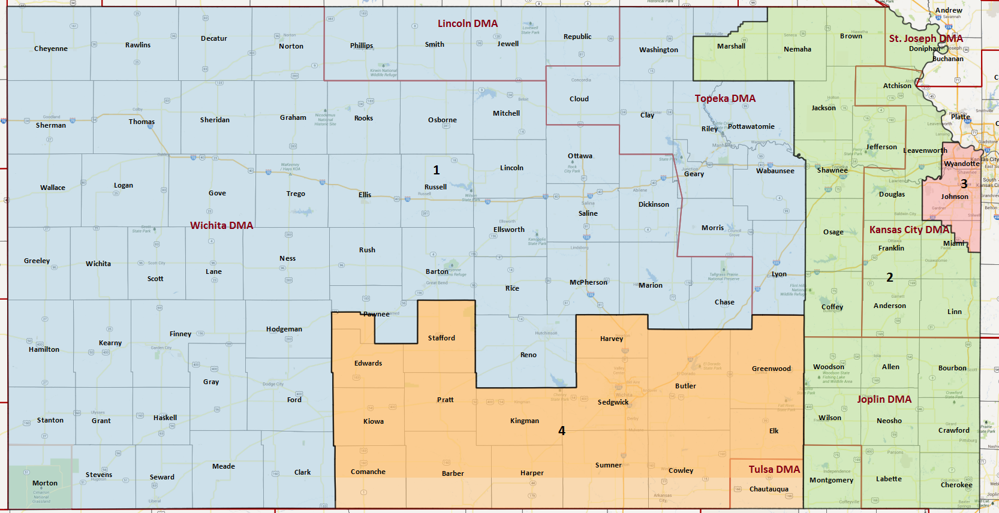

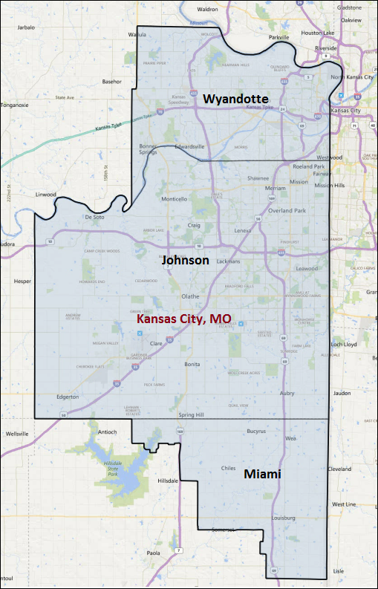

Media Market Costs

TV DMA | % of  CD | I.E.  35+ CPP | Cable CPP
KANSAS | 100% | $221 | $848
KS-03 TOTALS: | 100.0%
Radio Landscape
DMA | Universe | CPP

Digital Landscape

Presidential Statistics
Cycle | Candidate | Party | Vote
2012 | Obama | DEM | 45.1%
2012 | Romney | REP | 54.9%
2008 | Obama | DEM | 49.2%
2008 | McCain | REP | 50.8%

Congressional Statistics
Cycle | W/L | Candidate | Party | Vote
2014 | L | KULTATA | DEM | 39.9%
2014 | W | GORELL | REP | 60.1%
2012 | L | - | - | -%
2012 | W | YODER | REP | 100%

NCEC Data
Dem Performance: 46.5%
BVAP: 8.9%
Hispanic: 5.1%
Asian: 2.5%
Total Minority: 54.1%

Critical Dates
Filing Date: June 1st 2016
Primary Date: August 2nd 2016

Summary of 2014 Cycle Spending by Outside Groups
None

Summary of 2012 Cycle Spending by Outside Groups
None

Pre-Election Day Voting

Type of  “Early Voting” | Start Date  End Date | Percent of  Vote Cast Using this Method | Brief Description  (where/how  do people vote) | Timeframe (when does the majority of voting happen)
Early Vote In Person | Oct. 9th – Nov. 7th |  | County Elections office
Absentee Ballot/In person Absentee
Vote By Mail | Oct. 19th – Nov. 8th |  | Ballots are mailed out Oct. 19th and must be received by the county elections office by close of polls on election day

SECTION II: DISTRICT OVERVIEW

- District Overview and Data

  - Political Landscape
- Kevin Yoder was first elected to Congress in 2010. He did not face democratic opposition in 2012 and easily beat his democratic opponent Kelly Kultala 60-40 is 2014.
- There is no current democratic candidate filed to run against Yoder in 2016.
- The filing date for 2016 is June 1st.
- Yoder has over $2.3 million on hand.
- Yoder has been officially rebuked for skinny dipping while on an official trip to Israel.

  - District Demographics
Kansas' 3rd Congressional District is located in eastern Kansas and encompasses Wyandotte and Johnson counties, which included the Kansas City Metropolitan Area and portions of Douglas County, which includes part of Lawrence. The district includes Kansas City and the surrounding suburbs of Overland Park, Lenexa, Shawnee and Olathe

- Cook Partisan Voting Index: R+6
- Urban Population: 4.1%
- Rural Population: 17.6%
- Suburb Population: 78.3%
- Median Income: $64,949
- Poverty Status: 6.1%
- Military Veterans: 9.2%
- Race/Ethnic Origin: 82.7% White; 8.9 % African American; 2.5% Asian; 5.1% Hispanic

  - Electoral Context
- Senator Jerry Moran is up for reelection in 2016. No democratic candidates have announced. He does face a republican primary opponent. He did not have democratic opposition in 2014, instead faced independent and libertarian candidates. He won 53 – 42 – 4.

  - Press Presence
- The Kansas City Star
- KSHB, Kansas City

KS-03 Research

Kevin Yoder (Republican Incumbent) Vulnerabilities

Kevin Yoder was first elected to Congress in 2010. He was previously a member of the Kansas House of Legislature from 2003 to 2010. While in the state legislature he was the chair of the House Budget Committee and led the push to cut education funding by $142 million while cutting taxes for businesses. While in Congress, he has voted to repeal Obamacare, defund Planned Parenthood, and opposed the President’s DACA/DAPA Executive Order reliefs.

Top Hits

- Voted to defund Planned Parenthood
- Voted twice to block consideration of the Paycheck Fairness Act
- Was accused of engaging in a pay-to-play scheme with payday lending industry
- Voted for government shutdown
- Was chair of the House Budget Committee while in the State Legislature and led the push to cut education funding by $142 million while cutting taxes for businesses
- Enjoys the perks of Washington
- Went skinny dipping while on official trip to Israel
- 2009: Refused to take a sobriety test when he was pulled over for suspected DUI

Currently No Democratic Opponent

